Nguyễn Kiều Trang – 20205174

**Exercise 1:**

.eqv SEVENSEG_LEFT 0xFFFF0010

.eqv SEVENSEG_RIGHT 0xFFFF0011

.text

main:

li $a0, 0x66

jal SHOW_7SEG_LEFT

li $a0, 0x7

jal SHOW_7SEG_RIGHT

exit: li $v0, 10

syscall

endmain:

SHOW_7SEG_LEFT: li $t0, SEVENSEG_LEFT

sb $a0, 0($t0)

jr $ra

SHOW_7SEG_RIGHT: li $t0, SEVENSEG_RIGHT

sb $a0, 0($t0)

jr $ra

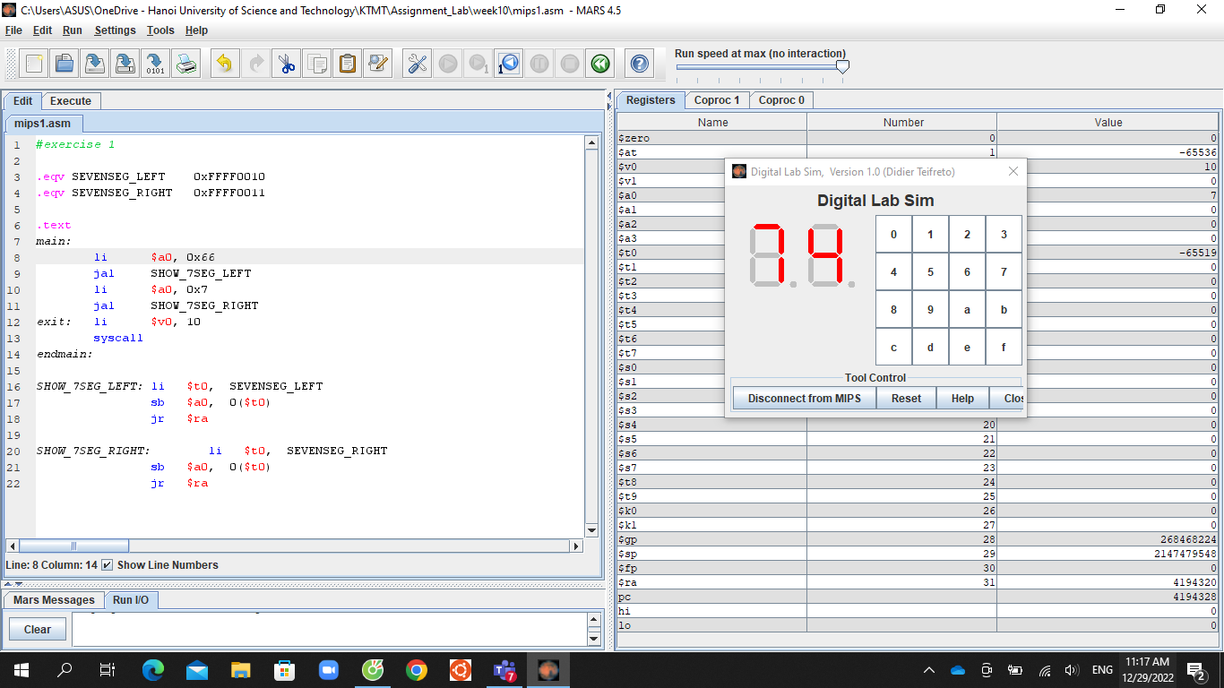

**Exercise 2:**

.eqv SEVENSEG_LEFT 0xFFFF0010

.eqv SEVENSEG_RIGHT 0xFFFF0011

.data

input: .asciiz "Input N: "

X: .word 0x3f,0x6,0x5b,0x4f,0x66,0x6d,0x7d,0x7,0xff,0x6f

.align 0

res: .space 80

.text

Nhapso:

#Input N

la $a0, input #address of input integer

li $v0, 4 #system call for string display

syscall

li $v0, 5 #read interger system call

syscall

move $s0, $v0 #store first integer in s0

Chia:

#lay hang don vi

li $t3, 10

div $s0,$t3

mflo $s0

mfhi $t1 #chu so hang don vi

#lay hang chuc

div $s0,$t3

mfhi $t2 #chu so hang chuc

main:

#lay dia chi mang X

la $s1, X

mul $t5, $t1, 4

add $t0, $s1, $t5

lw $a0, 0($t0)

jal SHOW_7SEG_LEFT

mul $t5, $t2, 4

add $t0, $s1, $t5

lw $a0, 0($t0)

jal SHOW_7SEG_RIGHT

exit: li $v0, 10

syscall

endmain:

SHOW_7SEG_LEFT: li $t0, SEVENSEG_LEFT

sb $a0, 0($t0)

jr $ra

SHOW_7SEG_RIGHT: li $t0, SEVENSEG_RIGHT

sb $a0, 0($t0)

jr $ra

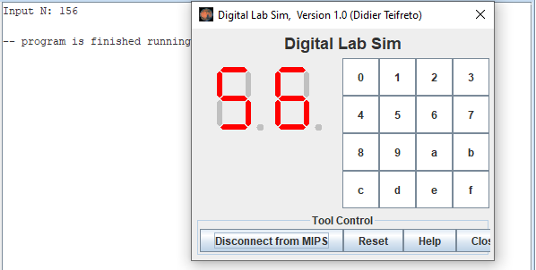

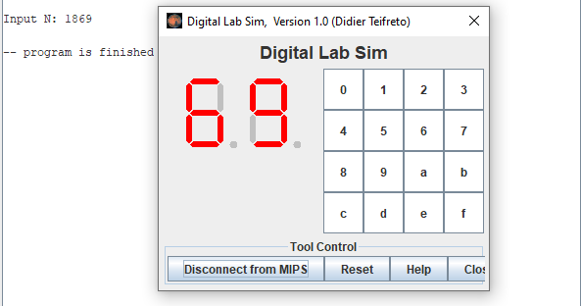

**Exercise 3:**

.eqv SEVENSEG_LEFT 0xFFFF0010

.eqv SEVENSEG_RIGHT 0xFFFF0011

.data

input: .asciiz "Input C: "

print: .asciiz "\nAscii: "

X: .word 0x3f,0x6,0x5b,0x4f,0x66,0x6d,0x7d,0x7,0xff,0x6f

.align 0

res: .space 80

.text

Nhapso:

#Input N

la $a0, input #address of input integer

li $v0, 4 #system call for string display

syscall

li $v0, 12 #read character system call

syscall

move $a3, $v0

#chuyen ki tu qua so nguyen

la $a0, print #address of input integer

li $v0, 4 #system call for string display

syscall

li $v0,1

move $a0,$a3

syscall

move $s0, $a0

Chia:

#lay hang don vi

li $t3, 10

div $s0,$t3

mflo $s0

mfhi $t1 #chu so hang don vi

#lay hang chuc

div $s0,$t3

mfhi $t2 #chu so hang chuc

main:

#lay dia chi mang X

la $s1, X

mul $t5, $t1, 4

add $t0, $s1, $t5

lw $a0, 0($t0)

jal SHOW_7SEG_LEFT

mul $t5, $t2, 4

add $t0, $s1, $t5

lw $a0, 0($t0)

jal SHOW_7SEG_RIGHT

exit: li $v0, 10

syscall

endmain:

SHOW_7SEG_LEFT: li $t0, SEVENSEG_LEFT

sb $a0, 0($t0)

jr $ra

SHOW_7SEG_RIGHT: li $t0, SEVENSEG_RIGHT

sb $a0, 0($t0)

jr $ra

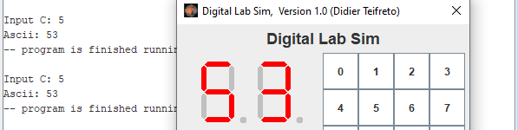

--

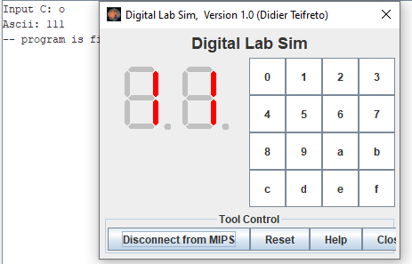

**Exercise 4:**

.eqv MONITOR_SCREEN 0x10010000

.eqv BLUE 0x000000FF

.eqv WHITE 0x00FFFFFF

.text

li $k0, MONITOR_SCREEN

add $t4,$k0,0

li $t0,0

li $t1,0

li $s1,8

loop1:

beq $t0,$s1,exit

addi $t0,$t0,1

li $t1,0

j loop2

loop2:

beq $t1,$s1,loop1

add $t2,$t1,$t0

div $t2,$t2,2

mfhi $t2

beq $t2,$zero,blue

j white

blue:

li $t3, BLUE

sw $t3, 0($t4)

add $t4,$t4,4

addi $t1,$t1,1

j loop2

white:

li $t3, WHITE

sw $t3, 0($t4)

add $t4,$t4,4

addi $t1,$t1,1

j loop2

exit:

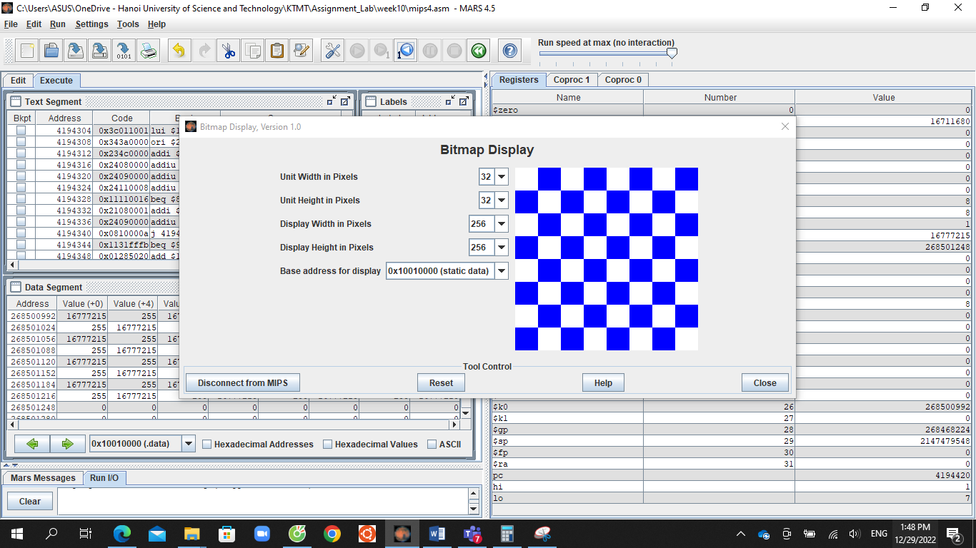

**Exercise 5:**

.eqv MONITOR_SCREEN 0x10010000

.eqv GREEN 0x0000FF00

.eqv RED 0x00FF0000

.eqv WHITE 0x00FFFFFF

.text

li $k0, MONITOR_SCREEN

add $t1,$k0,$zero

li $t2,64

li $a3,0

li $v0,5

syscall

add $s1,$v0,$zero #x1

li $v0,5

syscall

add $s2,$v0,$zero #y1

li $v0,5

syscall

add $s3,$v0,$zero #x2

li $v0,5

syscall

add $s4,$v0,$zero #y2

add $s5, $s2,$zero #copy y1

mul $t5,$s2,8

add $t5,$t5,$s1 #Toa do (x1,y1)

mul $t5,$t5,4

add $t5,$t5,$k0

mul $t4,$s4,8 #Toa do (x2,y2)

add $t4,$t4,$s3

mul $t4,$t4,4

add $t4,$t4,$k0

## set the theme color

loop:

slt $t3,$a3,$t2

beq $t3,$zero,rectangle1

li $t0, WHITE

sw $t0, 0($t1)

addi $t1,$t1,4

addi $a3,$a3,1

j loop

#edge

rectangle1:

slt $t3,$t5,$t4

beq $t3,$zero, newcoords

mul $t6,$s5,8

add $t6,$t6,$s3 #Toa do (x1,y1)

mul $t6,$t6,4

add $t6,$t6,$k0

slt $t0,$t5,$t6

beq $t0,$zero,newrow

li $t0, RED

sw $t0, 0($t5)

addi $t5,$t5,4

j rectangle1

newrow:

addi $s5,$s5,1

mul $t5,$s5,8

add $t5,$t5,$s1 #Toa do (x1,y1)

mul $t5,$t5,4

add $t5,$t5,$k0

j rectangle1

newcoords:

addi $s1,$s1,1

addi $s2,$s2,1

addi $s3,$s3,-1

addi $s4,$s4,-1

add $s5, $s2,$zero

mul $t5,$s2,8

add $t5,$t5,$s1 #Toa do (x1,y1)

mul $t5,$t5,4

add $t5,$t5,$k0

mul $t4,$s4,8 #Toa do (x2,y2)

add $t4,$t4,$s3

mul $t4,$t4,4

add $t4,$t4,$k0

j rectangle2

#backfround

rectangle2:

slt $t3,$t5,$t4

beq $t3,$zero, exit

mul $t6,$s5,8

add $t6,$t6,$s3 #Toa do (x1,y1)

mul $t6,$t6,4

add $t6,$t6,$k0

slt $t0,$t5,$t6

beq $t0,$zero,newrow2

li $t0, GREEN

sw $t0, 0($t5)

addi $t5,$t5,4

j rectangle2

newrow2:

addi $s5,$s5,1

mul $t5,$s5,8

add $t5,$t5,$s1 #Toa do (x1,y1)

mul $t5,$t5,4

add $t5,$t5,$k0

j rectangle2

exit:.

